PART 1: The Challenge
Background: Safely Riding a Car.
You are tasked to design a combinational logic circuit that operates an alarm in a car whenever the driver and/or passenger seats are occupied, and the seatbelts are not fastened when the car is started. The active-HIGH signals DRIV and PASS indicate the presence of the driver and passenger, respectively, and are taken from pressure-actuated switches in the seats. The signal IGN is active-HIGH when the ignition switch is on. The signal 𝐵𝐸𝐿𝑇D’ is active LOW and indicates that the driver’s seatbelt is unfastened. 𝐵𝐸𝐿𝑇𝑃’ is the corresponding signal for the passenger seatbelt.
The alarm will be activated (LOW) whenever the car is started and either of the front seats is occupied and its seatbelt is not fastened.
Your goal is to design the logic circuit needed to fulfill the above conditions. You must use the problem-solving process (PSP) taught during the lectures alongside the Boolean design process (BDP). Below is a step-by-step guide to assist you in this endeavour. Your tutors will also assist you in this.
Step 1: Understand and Define the Problem (Analyse)
The problem is to design a combinational logic circuit of a safety alarm in a car. The alarm should be triggered when the car is started but seatbelt is not fastened. The inputs in the system are: DRIV and PASS (indicating whether the driver or passenger seat is occupied), IGN (indicating that the ignition is turned on – or the car is started), BELTD’ and BELTP’ indicating whether the driver and passengers’ seatbelts are unfastened (active LOW). The output is the ALARM (active LOW- ignition on and driver OR passenger is seated without seatbelt fastened).

Step 2: Organise and Describe the Data
Symbol | Description | Type | Value
DRIV | Driver is in the seat | Input | HIGH (1=present)
PASS | Passenger is in the seat
IGN | Ignition is ON |  | HIGH (1=ON)
BELTD’ | If drive is in the seat but belt unfastened |  | LOW (0 = unfastened)
BELTP’ | If drive is in the seat but belt unfastened
ALARM | If any condition is not satisfied | Output | LOW (0 = ON)

Step 3: Plan the Solution (Design the Algorithm)
3.1 Algorithm (in plain English)
1) Monitor Ignition switch – IGN must be HIGH
2) Check if drive is seated and driver’s belt is not fastened
DRIV = 1 and BELTD’ = 0
3) Check if passenger is seated and driver’s belt is not fastened
PASS = 1 and BELTP’ = 0
4) If either condition is True and IGN = 1, the alarm activate (LOW)
5) Otherwise, alarm remains HIGH
3.2 Truth Table
INPUTs |  |  |  |  | OUTPUT
DRIV | PASS | BELTD’ | BELTP’ | IGN | ALARM’
0 | 0 | 0 | 0 | 1 | 1
0 | 0 | 0 | 1 | 1 | 1
0 | 0 | 1 | 0 | 1 | 1
0 | 0 | 1 | 1 | 1 | 1
0 | 1 | 0 | 0 | 1 | 1
0 | 1 | 0 | 1 | 1 | 1
0 | 1 | 1 | 0 | 1 | 1
0 | 1 | 1 | 1 | 1 | 1
1 | 0 | 0 | 0 | 1 | 0
1 | 0 | 0 | 1 | 1 | 0
1 | 0 | 1 | 0 | 1 | 1
1 | 0 | 1 | 1 | 1 | 1
1 | 1 | 0 | 0 | 1 | 0
1 | 1 | 0 | 1 | 1 | 0
1 | 1 | 1 | 0 | 1 | 0
1 | 1 | 1 | 1 | 1 | 1

3.3 Boolean Expressions (SOP)
$$ALARM= DRIV.PASS’.BELTD’.BELTP’.IGN + DRIV.PASS’.BELTD’.BELTP.IGN$$
$+ DRIV.PASS.BELTD’.BELTP’.IGN + DRIV.PASS.BELTD’.BELTP.IGN$
$$+ DRIV.PASS.BELTD.BELTP’.IGN$$

3.4 Flowchart
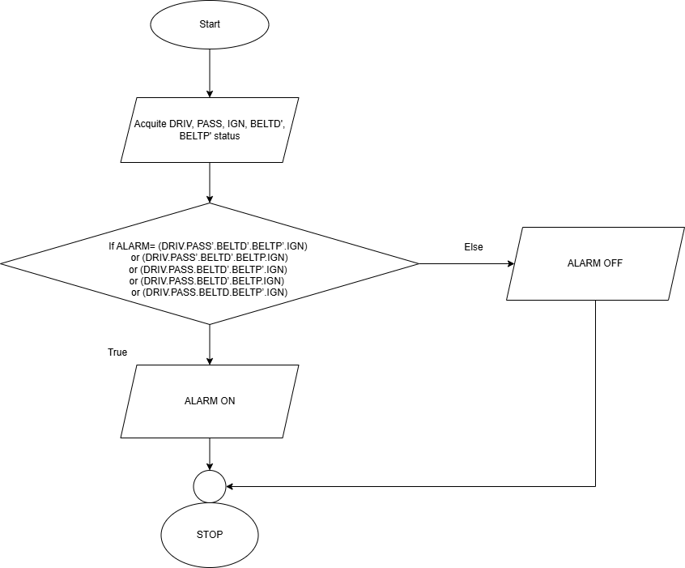
3.5 Pseudocode
IF ALARM= (DRIV.PASS’.BELTD’.BELTP’.IGN)
OR (DRIV.PASS’.BELTD’.BELTP.IGN)
OR (DRIV.PASS.BELTD’.BELTP’.IGN)
OR (DRIV.PASS.BELTD’.BELTP.IGN)
OR (DRIV.PASS.BELTD.BELTP’.IGN)
ALARM IS LOW #ON
ELSE
ALARM IS HIGH #OFF
Step 4: Test and Refine the Solution (Debug and Verify)
INPUTs |  |  |  |  | OUTPUT
DRIV | PASS | BELTD’ | BELTP’ | IGN | ALARM’
0 | 1 | 1 | 1 | 1 | 1
1 | 0 | 0 | 0 | 1 | 0
1 | 0 | 0 | 1 | 1 | 0
1 | 0 | 1 | 0 | 1 | 1
1 | 0 | 1 | 1 | 1 | 1
1 | 1 | 0 | 0 | 1 | 0
1 | 1 | 0 | 1 | 1 | 0
1 | 1 | 1 | 0 | 1 | 0
1 | 1 | 1 | 1 | 1 | 1

